WEEK NUMBER: | 8
STUDENT NAME: | Anas Al Azad
STUDENT ID: | [YOUR STUDENT ID]
Week 8 – RNN, LSTM/GRU and Attention (+ Lab 8 deliverable)
My checklist for this week – ticked = done (notebook, plots and my one-page summary are in the Lab 8 folder of my repo), unticked = still on my to-do list.
LAB 8 CHECKLIST (☒ = done, ☐ = still to do) |  | STATUS
☒ | Read the Lab 8 sheet (sequence data, RNN, LSTM/GRU, attention + positional encoding, the “remember the first digit” task) | Done
☒ | Setup + Part 1: measured the vanishing gradient for RNN / LSTM / GRU (gradient plot) | Done
☒ | Part 2: trained RNN / LSTM / GRU for T = 5, 10, 20, 60 with 3 seeds each | Done
☒ | Part 2 experiment: hidden layer 32 → 128 units at T = 20 | Done
☒ | Part 3: self-attention for T = 10, 20, 60 + plotted where it looks (attention weights) | Done
☒ | Part 3 ablation: removed positional encoding | Done
☒ | Results table (model × T) + answered the 3 checkpoint questions | Done
☒ | Deliverable: one-page summary (Lab8_Summary.docx / .pdf) | Done
☒ | Extra: 40 epochs instead of 15 at T = 20 (memory limit or just training?) | Done
☐ | Put my student ID on the summary and export it to PDF again | To do
☐ | Open / re-run the notebook on my laptop and take the screenshots | To do
☐ | Hand in the notebook + one-page summary | To do
☐ | Add my screenshots (yellow boxes below) | To do
Progress: 9/13 items done

WEEK # | 8
Dates covered: | 1-7 October 2026
Lab tasks | What I did | TIME SPENT | Learning & Problems
Theory – sequences & memory  Lab 8 sheet sections 1–2 | - Read how an RNN keeps a hidden state, why early info fades (vanishing gradient), how LSTM/GRU add gates + a cell state, and how attention links any two steps directly but needs positional encoding and costs O(T²).  - Understood the test task: sequences of T random digits, label = the first digit, so accuracy only measures memory (chance = 0.10). | 1 h | Learning:  - Hidden state = the RNN's memory, overwritten every step.  - Gates = learned switches for what to write / keep / forget.  - Attention is parallel and has no distance problem, but doesn't know order by itself.  Problems:  - None really for this one.
Part 1 – vanishing gradients  Lab8_RNN_LSTM_Attention.ipynb | - Ran the setup (3 sequences of 10 digits + labels ✔) and the gradient cell: fed a 50-step random sequence through each layer and measured the gradient at every input step.  - Gradient at the last step / first step: RNN 1.5e+13, LSTM 7.8e+10, GRU 2.8e+10 (Fig 8.1) – same as the sheet's typical result. | 0.5 h | Learning:  - The gradient shrinks exponentially going back in time – a straight line on a log plot.  - Gates help (LSTM/GRU shrink ~100× less) but don't fix it.  Problems:  - None really for this one.
Part 2 – RNN vs LSTM vs GRU  3 models × 4 lengths × 3 seeds | - Trained all 36 models (15 epochs each) – took 212 s on CPU (sheet said ~5 min).  - Mean accuracy for T = 5 / 10 / 20 / 60: RNN 1.00 / 0.66 / 0.10 / 0.10, LSTM 1.00 / 0.96 / 0.47 / 0.09, GRU 1.00 / 1.00 / 0.10 / 0.09 (Fig 8.3).  - Experiment 32 → 128 units at T = 20: RNN 0.77, LSTM 0.59, GRU 1.00 (sheet: 0.85 / 0.59 / 1.00). | 1.5 h | Learning:  - All three are perfect at T = 5; the plain RNN breaks first, the gated ones hold on longer, but by T = 60 everything is at chance.  - A bigger hidden state helped a lot at T = 20 (GRU 0.10 → 1.00).  Problems:  - Same settings, different seeds = very different results (RNN at T = 10: 0.79 / 1.00 / 0.19; LSTM at T = 20: 0.32 / 0.18 / 0.90) – had to look at all 3 runs, not just the mean.  - My RNN-128 result (0.77) is a bit lower than the sheet's 0.85 – probably a different CPU/PyTorch version; everything else matched exactly.
Part 3 – self-attention  + attention plot + ablation | - Self-attention with positional encoding: 1.00 / 1.00 / 1.00 for T = 10 / 20 / 60 – even T = 60 is easy because step 1 is only one hop from the last step.  - Attention plot at T = 20: the last position puts 0.95 (head 0) and 0.80 (head 1) of its weight on position 0 – it looks straight at the first digit (Fig 8.2).  - Ablation without positional encoding: 0.26 (T = 10) and 0.18 (T = 30).  - Worked out why: without order, the best possible guess is the most common digit in the sequence – I simulated that = 0.27 / 0.20, almost exactly what the model got. | 1.5 h | Learning:  - Attention without positions = a bag of digits (permutation-invariant).  - Positional encoding (sin/cos) gives every step a unique tag – that's what Transformers/LLMs rely on.  Problems:  - The sheet doesn't say why the ablation lands at 0.26 instead of chance (0.10) – the model can still count the digits, it just can't tell which one came first (I checked this with a simulation, see above).
Deliverable + extra  Lab8_Summary.pdf, extra experiment | - Wrote the one-page summary: results table (Parts 2 + 3), gradient plot, attention plot and my answers to the 3 checkpoint questions (make_summary.py builds it from the notebook's results.json, so it updates if I re-run).  - Extra: 40 epochs instead of 15 at T = 20 → LSTM 0.47 → 0.93, GRU 0.10 → 0.96, RNN 0.55 (one seed still stuck at 0.10). | 1.5 h | Learning:  - At T = 20 it's partly a training problem: the gated models CAN learn the dependency, they just need many more updates because the signal from step 1 is so weak.  Problems:  - Fitting everything on ONE page – had to put the two plots side by side and keep each answer to 3 sentences.
TOTAL TIME THIS WEEK |  | 6 h | + ~30 min screenshots & hand-in

Screenshots:
Figures 8.1–8.3 come straight out of my Lab8_RNN_LSTM_Attention.ipynb (8.1 and 8.2 are the two plots the deliverable asks for). The yellow boxes are screenshots I still need to add.
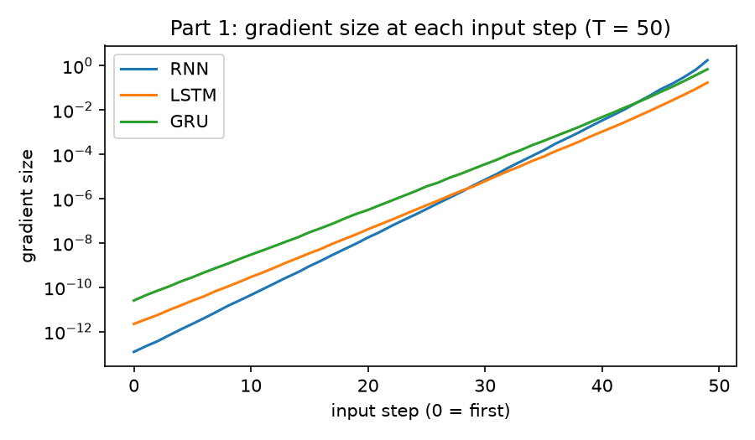
Figure 8.1 – Part 1 – gradient size at each of the 50 input steps (log scale)
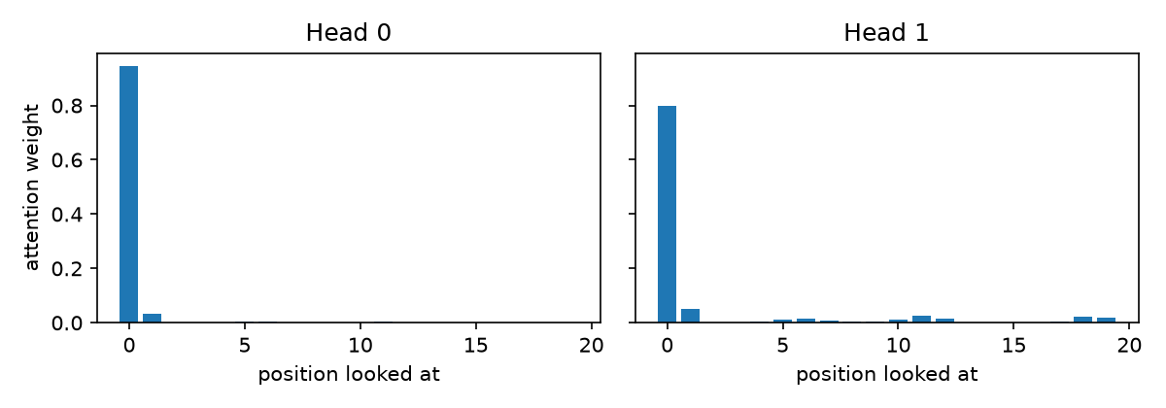
Figure 8.2 – Part 3 – where the last position looks at T = 20 (averaged over 200 sequences)
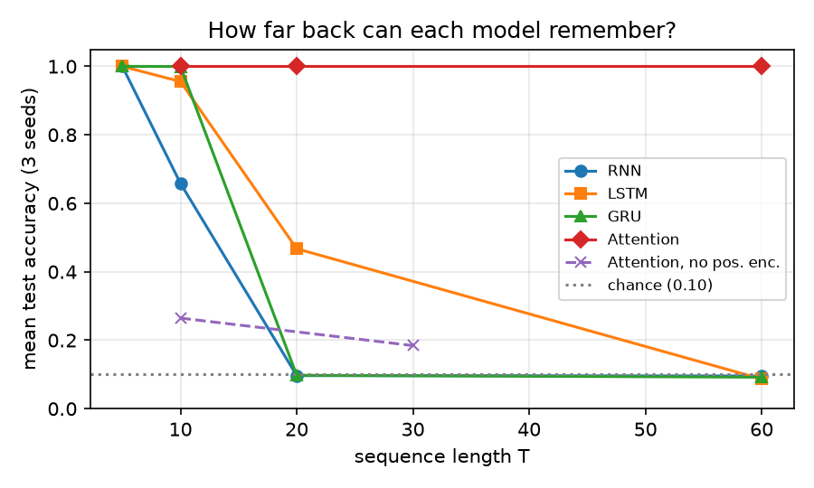
Figure 8.3 – mean test accuracy vs sequence length for every model (chance = 0.10)
[SCREENSHOT 8.1] Notebook – setup + Part 1
What to capture: the setup output (3 rows of 10 digits + the 3 labels) and the Part 1 cell with its 3 ratio lines (1.5e+13 / 7.8e+10 / 2.8e+10) and the gradient plot.
Save as Lab 8/screenshots/8.1_setup_and_part1.png then run python _tools/insert_screenshots.py (or just paste the image here and delete this box).
Screenshot 8.1 – Notebook – setup + Part 1
[SCREENSHOT 8.2] Notebook – Part 2 results
What to capture: the 12 printed lines for rnn / lstm / gru × T = 5, 10, 20, 60 (+ “took …s”) and the 3 lines of the 128-unit experiment.
Save as Lab 8/screenshots/8.2_part2_results.png then run python _tools/insert_screenshots.py (or just paste the image here and delete this box).
Screenshot 8.2 – Notebook – Part 2 results
[SCREENSHOT 8.3] Notebook – Part 3 attention
What to capture: the attn lines (T = 10, 20, 60 all 1.00) and the attention plot with both heads.
Save as Lab 8/screenshots/8.3_part3_attention.png then run python _tools/insert_screenshots.py (or just paste the image here and delete this box).
Screenshot 8.3 – Notebook – Part 3 attention
[SCREENSHOT 8.4] Notebook – ablation + results table
What to capture: the attn_nopos lines (0.26 / 0.18) and the results table (model × T).
Save as Lab 8/screenshots/8.4_ablation_and_table.png then run python _tools/insert_screenshots.py (or just paste the image here and delete this box).
Screenshot 8.4 – Notebook – ablation + results table
[SCREENSHOT 8.5] My one-page summary
What to capture: Lab8_Summary.pdf open on screen (whole page visible, with your student ID on it).
Save as Lab 8/screenshots/8.5_summary_pdf.png then run python _tools/insert_screenshots.py (or just paste the image here and delete this box).
Screenshot 8.5 – My one-page summary

